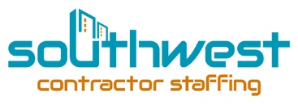

AZCR Staffing Immigration Policy

IMMIGRATION LAW COMPLIANCE POLICY AND ACKNOWLDGEMENT FORM

SCS STAFFING is committed to employing only those individuals who are authorized to work in the United States. SCS STAFFING does not unlawfully discriminate on the basics of citizenship or national origin. In compliance with the immigration Reform and Control Act of 1996, each new employee, as a condition of employment, must complete the Employment Eligibility Process. The Federal Government currently provides approximately 29 documents from which employees may choose in order to confirm eligibility of employment which must be provided to AZCR STAFFING. The employee must also complete Section 2 of the I-9 form
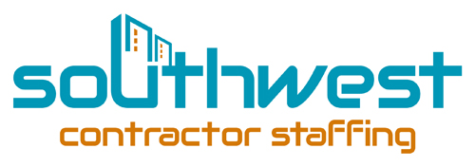
- I understand that SCS STAFFING only hires individuals who are authorized to work in the United States.
- I understand that SCS STAFFING does not unlawfully discriminate on the basics of citizenship or national origin.
- I understand that under federal law I am required to provide AZCR STAFFING with valid and accurate documents to establish my identity for authorization to work in the United States, and I am required to complete section one of the I-9 form completely and truthfully.
- By my signature below I affirm that I am legally eligible for employment in the United States
- I hereby state that all information provided to AZCR STAFFING on the I-9 form is true and accurate. I am aware that false statements, misrepresentations of fact or material omission may result in the termination of employment.
- I understand that I am on At–Will Employment and that SCS STAFFING and I both have the right to terminate my employment at any time for any reason or no reason, with or without cause and with or without notice. I understand that violation of company policies and practices, including the immigrations law compliance policy, may result in discipline, up to and including termination.
- I understand and agree to comply with all company policies, practices, and procedures.

Employee name: (print) ______________________________________________________

Employee Signature: ______________________________________________________

Date: _________________________________________

CONFIDENTIAL LEGAL DOCUMENT PROPERTY OF SCS STAFFING
2440 W Osborn RD Phoenix, AZ 85015 602-870-3515, fax 602-870-3536
www.southwestcontractorstaffing.com

